Songs and the Sky
An exhibition of art and music
April 28 – June 18, 2016

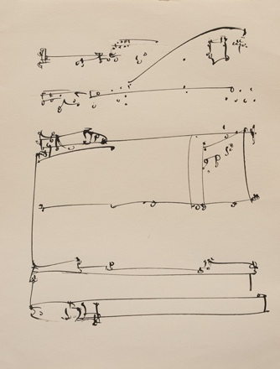

Bruce Silverstein Gallery is pleased to present Songs and the Sky, an exhibition of art and music.

Artworks by Lisette Model, Barbara Morgan, Aaron Siskind, Frederick Sommer, and Alfred Stieglitz will be paired with musical compositions by Ernest Bloch, John Cage, Arnold Schoenberg, Henry Cowell, and Christopher Washburne. Historically and conceptually relevant musical compositions were chosen to provoke, compliment, enhance, and challenge a reading of the visual artworks. Music served as literal or ideological inspiration for these artists, who sought to create work with the equivalent potential to communicate or translate abstract concepts directly.

The exhibition title derives from Alfred Stieglitz’s historic series, Songs of the Sky, the artist’s original title for the Equivalents (1925-1937). Similar to notes in a musical score, these images of cloud patterns form an abstract, universal visual language analogous to the artist's inner state, emotion, and ideas. This exhibition is a rare opportunity to view such a large collection of Equivalents.

The exhibition encourages visitors to pause, listen and experience the synthesis of art and music. The artists and composers are paired in the gallery as follows:

Lisette Model / Arnold Schoenberg
Barbara Morgan / Henry Cowell
Aaron Siskind / John Cage
Frederick Sommer / Chris Washburne
Alfred Stieglitz / Ernest Bloch

Please contact the gallery at inquiries@brucesilverstein.com or (212) 627-3930 for more information.

Join us on Twitter @BSG_NYC, Instagram @brucesilverstein, Facebook, and Google+.
#brucesilverstein #songsandthesky
Upcoming
Paul Outerbridge
Opening June 23, 2016

